

Standard User Manual
English - Version 1.7
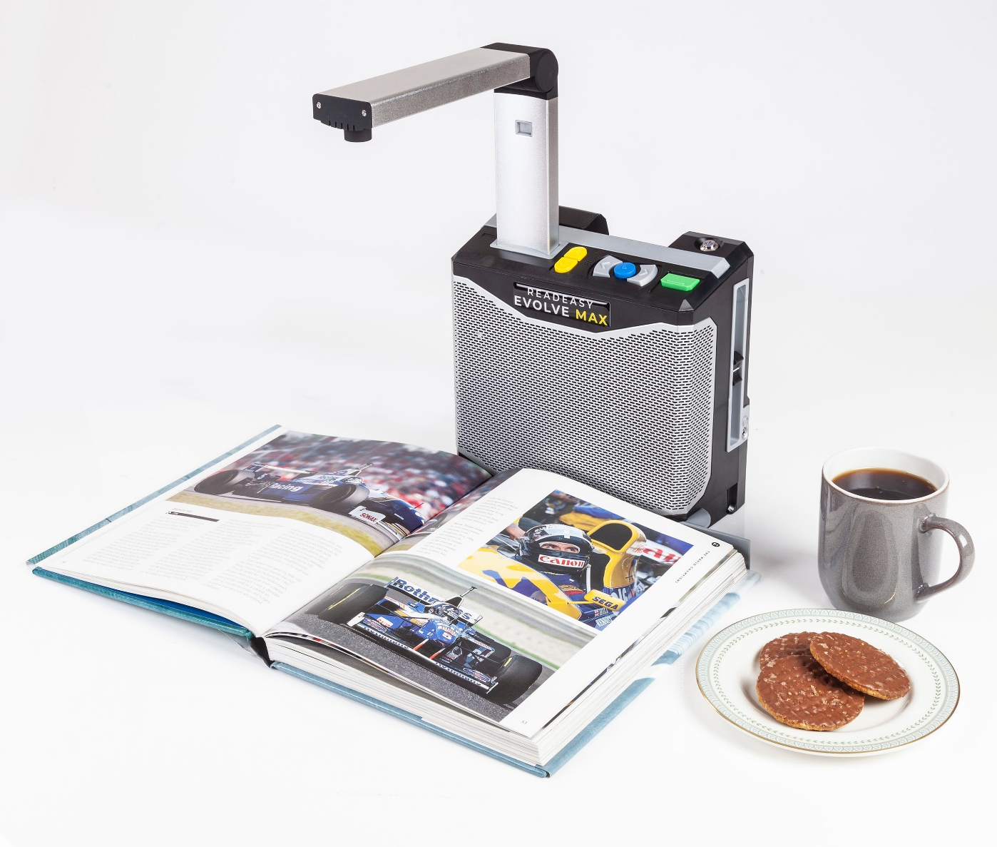
Copyright 2026, Visionaid International Ltd, all rights reserved.
Table of contents:
General description 5
Improvement program 5
Ownership and intellectual property 6
Safety 7
Pacemaker safety guidelines 7
General safety guidelines 7
Box contents 8
Unpacking 8
Carry Handle 9
Positioning for use 9
Camera 10
Removing the camera from its stored position 10
Unfolding the camera 10
Plugging in the camera 11
Un-plugging the camera 12
Returning the camera to its stored position 12
Plugging in 13
Turning on / off 14
LED lighting on / off 15
Audio 16
Volume adjustment 16
Headphone socket and headphones 16
Pairing to Bluetooth Audio Device 17
Positioning documents for capture 17
A4 page (US Letter) document positioning 17
Larger format documents 18
Cylindrical objects (e.g. tins) 19
Positioning Tips 19
Controls 20
Capturing a document 21
Navigation 22
Table navigation 23
Speech Control 23
Cycle recognition profiles 24
Main menu 25
Recognition profiles 25
Menu settings 27
Advanced Settings 28
About 29
Languages 29
Obtaining additional voice sets / features 29
Activating additional voice sets / features 29
Supported languages 29
Upgrading software 31
Checking your existing software version 31
Determining the latest version available 31
Obtaining the latest software 31
How to upgrade 31
FAQ and Troubleshooting 31
Terms and conditions of sale 33
Appendix A: Technical Information 34

General description
Congratulations on choosing the ReadEasy Evolve MAX digital capture reading system.
The ReadEasy Evolve MAX combines ease of use with the highest accuracy, best quality speech output and the world’s fastest full-page text recognition. It can capture and read any printed material up to A3 in size, such as letters, bank statements, newspapers, food packaging, etc. and reads the text aloud using natural-sounding voices.

Improvement program
Users are the best people to help us further improve and develop our products so if you have any ideas or suggestions, no matter how small, please do contact us:

Email:
suggestions@visionaid.com


Post:
ReadEasy Evolve MAX Suggestions
Visionaid International Ltd.
Bridge Lodge
Spalding
Lincolnshire
PE11 3AU
United Kingdom

Phone:
+44 (0) 1775 711 977
Thank you, and enjoy your ReadEasy Evolve MAX reading machine!

Ownership and intellectual property
The software installed on the ReadEasy Evolve MAX makes use of third-party software libraries that are redistributed under their own respective licenses.
- Copyright (C) 2000-2015, Intel Corporation, all rights reserved.
- Copyright (C) 2009-2011, Willow Garage Inc., all rights reserved.
- Copyright (C) 2009-2015, NVIDIA Corporation, all rights reserved.
- Copyright (C) 2010-2013, Advanced Micro Devices, Inc., all rights reserved.
- Copyright (C) 2015, OpenCV Foundation, all rights reserved.
- Copyright (C) 2015, Itseez Inc., all rights reserved.
- Third party copyrights are property of their respective owners.

Safety

Pacemaker safety guidelines
The ReadEasy Evolve MAX contains magnets in the main unit and the camera arm. The optional Wireless Control Pad with Control Pad Simplifier also contains magnets. It is not recommended to put any of these items on or near your chest if you have a pacemaker fitted.
If you have a pacemaker, please consult the manufacturer’s guidelines for safe operating distances.
Do not place any of the ReadEasy Evolve MAX near inadequately shielded medical devices.

General safety guidelines
- Please handle the ReadEasy Evolve MAX with care as rough handling may damage internal components and will void your warranty.
- Always operate the unit in a place where the temperature is between 10°and 35°C (50°and 95°F). Do not expose to excessive heat, cold or direct sunlight.
- Keep the unit away from wet areas, rain and other sources of fluid, moisture and chemicals. Do not submerge the unit.
- Do not attempt to repair the unit; any unauthorised attempt will void the product warranty. Please contact your distributor.
- Use only the supplied power adapter.
- Always unplug the ReadEasy Evolve MAX before cleaning. Only use a soft cloth to clean the exterior. Do not use cleaning agents or abrasive materials as they will damage your unit.
- Use of the ReadEasy Evolve MAX other than as described in this manual will exclude it from warranty.

Box contents
Your ReadEasy Evolve MAX box contains the following items:
- ReadEasy Evolve MAX digital capture reading system.
- ReadEasy Evolve MAX camera (stored in the back of the ReadEasy Evolve MAX).
- Power brick and power cable.
- Quick Reference Guide.
- This User Manual.
- Over ear headphones.
- Optional Wireless Control Pad (if Keypad Feature Pack purchased).
If any of these items are missing from your box, please contact your local distributor immediately.

Unpacking
Lift out the cardboard tray containing the power brick (in its own box), power cable, headphones and documentation.
Then lift the ReadEasy Evolve MAX out of the box and carefully remove its side packaging.
Place the ReadEasy Evolve MAX onto a stable flat surface where it is going to be used.
If you have purchased the optional Feature Pack, the Wireless Control Pad will also be included. Remove this if present and required.
5) Keypad (optional)

Carry Handle
The ReadEasy Evolve MAX features an integrated grey carry handle making it safe and easy to move from room-to-room.
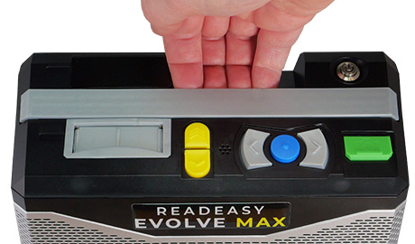
The carry handle is built into the top of the unit. It sits flush when not in use. By lifting the handle into its raised position, it is easy to grasp and move the unit.
Slide upwards

You can lower the handle back down by gently pushing it down until it sits flush with the unit.

Positioning for use
When placing the ReadEasy Evolve MAX onto a surface for use, ensure it is clean, flat and large enough to position the items you wish to read.
Ensure that the unit is not directly underneath any bright lighting, as this could affect its accuracy when reading glossy documents.

Camera
The ReadEasy Evolve MAX features a unique, magnetised, easy release camera system. The camera needs to be placed into the camera slot before capturing your reading material.

Removing the camera from its stored position
The camera is stored within the ReadEasy Evolve MAX, at the back of the unit, along the bottom. With the ReadEasy Evolve MAX facing towards you, run your fingers 1 inch (2.5cm) up the back of the left edge. You will feel a half circle shaped cut-out. Push the camera head backwards using this recess and fully remove it.
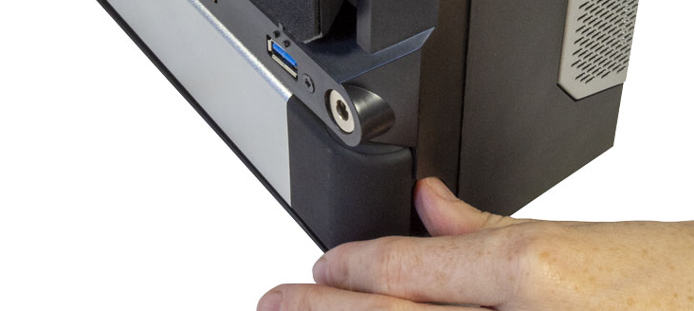

Unfolding the camera
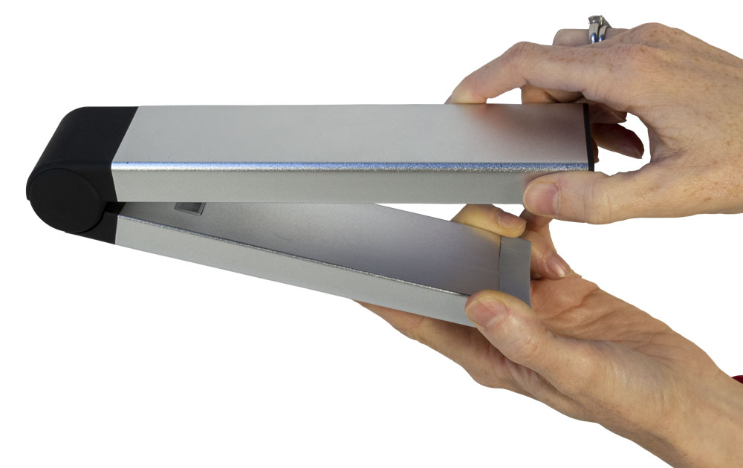
With the camera removed from the unit, it then needs to be unfolded. When the camera is folded, the part of the camera that will insert into the unit is slightly shorter. It also has a rectangular USB port which sits flush with the bottom of the shorter section.
Unfold the camera (90 degrees) so it is ready to be inserted into the camera position.

Plugging in the camera
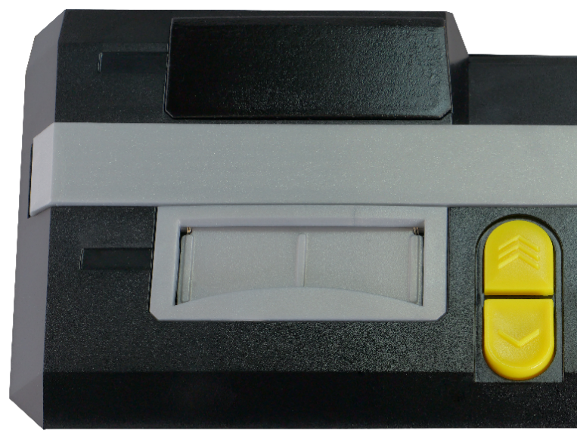
The slot for the camera (coloured silver) is located on the top of the ReadEasy Evolve MAX unit, at the front, 1.4 inches (3.5cm) from the left-hand side. The slot has a spring-loaded dust cover.
Camera slot
With the shorter arm (containing the USB port) facing downwards and the other part of the arm facing towards you, angle the camera head a few degrees forwards and slowly insert the camera into the camera slot.
The camera will slide down approximately 1.5 inches (4 cm).
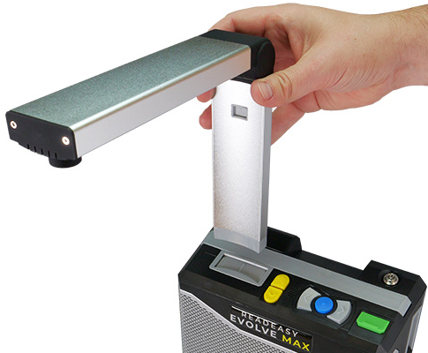
Once in position, you may need to apply a small amount of downwards force to connect the camera fully. As you do you will feel it positively locate into position.
If the ReadEasy Evolve MAX is already on when you insert the camera it will say “Camera connected”.
The camera will only go into its slot one way round and it does not require much force so please insert it carefully.

Un-plugging the camera
There is no need to un-plug, fold and store the camera after each use. This only needs to be done when transporting the unit.
To disconnect the camera, grasp it firmly on the upright part (above the camera slot). Place your other hand on the main unit itself and then pull the camera upwards. If you pull the upright part slightly towards you (with a small amount of force) as you lift it upwards, it reduces the force needed to remove the camera.
If the ReadEasy Evolve MAX is already on when you unplug the camera it will say “Camera disconnected”.

Returning the camera to its stored position
With the camera removed, gently fold the camera in at the hinge by holding onto both sections. Then return it to the back of the unit for safe storage in the opposite way to which you removed it.
It magnetises back into position and will only correctly fit one way round, with the shorter edge facing towards you and the rounded hinge to the left.

Plugging in
- Plug the power cable into the power brick.
- Plug the tip of the power brick into the ReadEasy Evolve MAX’s power socket. With the ReadEasy Evolve MAX facing towards you, run your index finger up the back of the unit on the far left-hand side. 2.5 inches (6cm) up, you should feel a round area with a round recess. This is where the tip of the power cable is inserted.
- Insert the mains plug into a wall socket & ensure it’s switched on.
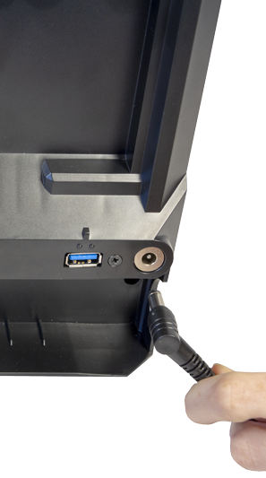

Turning on / off
To turn on the ReadEasy Evolve MAX, ensure it is plugged in, the mains power is switched on and that the camera is connected. Then, press and release the on / off button.
The on/off button is located on the top of the ReadEasy Evolve MAX, 1 inch (2.5 cm) from the back and 1.25 inches (3 cm) from the right edge. It is a round button which is recessed in a round hole.
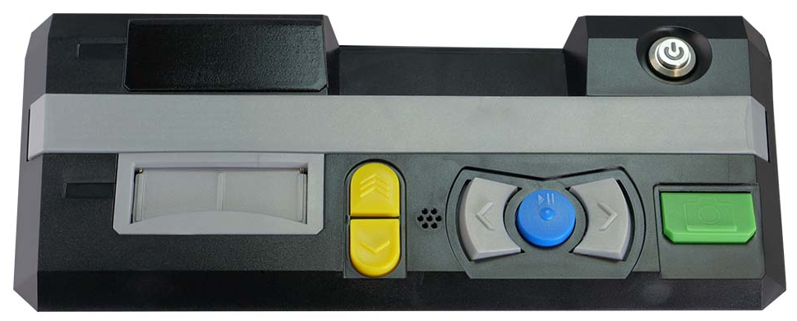
On / off button
Once pressed and released, the on / off button will illuminate in blue. After 3 seconds, an audible beep will sound (if the volume is up) and 15 seconds after that the ReadEasy Evolve MAX will announce, “ReadEasy is ready”.
To turn the ReadEasy Evolve MAX off, press the on / off button again. The ReadEasy Evolve MAX will announce “ReadEasy is turning off”.
IMPORTANT!
If you wish to unplug the unit after turning it off, please either wait 10 seconds after it announces “Goodbye” or ensure the blue power LED is no longer lit, to ensure it is fully off.

LED lighting on / off
The ReadEasy Evolve MAX’s camera is optimised to work in low light levels without its integrated LED lighting.
By default, its LEDs are turned off. In most scenarios should be kept off. They should only be switched on if there is very low ambient light.
If capturing a glossy document, using the integrated LED lighting can cause reflections which may impact the speech accuracy. Therefore, if you are having difficulties with glossy documents, ensure the ReadEasy Evolve MAX’s LED lights are switched off.
The lights are controlled by a rocker switch. This is located on the underside of the camera arm approx. 1.25 inches (3 cm) from the back of the head, in the middle.
To switch the light on, rock the switch to the right. To switch off, rock the switch to the left.
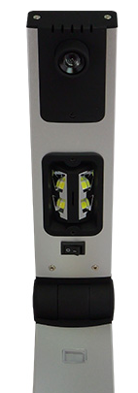
Lighting Rocker Switch
Light On
Light Off

Audio

Volume adjustment
To increase or decrease the volume, raise or lower the vertical volume slider. This is located on the right edge of the machine, 1.5 inches (4 cm) from the back.

Headphone socket and headphones
The ReadEasy Evolve MAX includes a pair of over-ear headphones. They have a standard 3.5 mm audio jack connector.
The loudspeakers will automatically mute as soon as the headphones are plugged in. To alter the headphone volume, use the volume slider.
The headphone socket is located on the right-hand edge of the machine, 3 inches (8 cm) from the front and 2.5 inches (6.5 cm) up from the bottom.
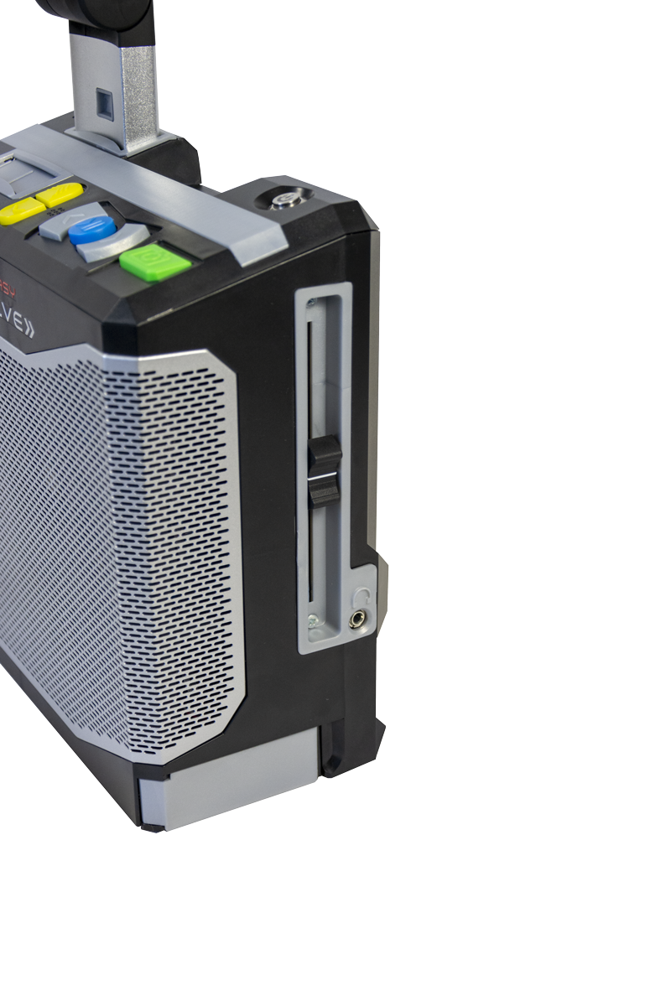
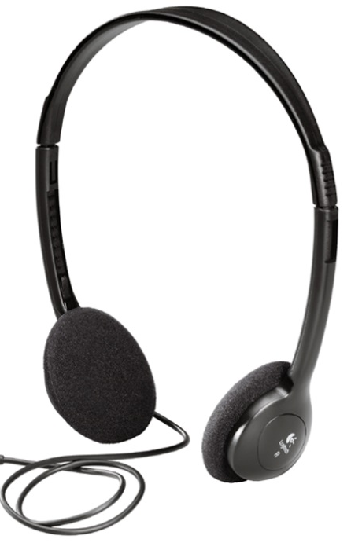
Volume slider
Headphone socket

Pairing to Bluetooth Audio Device
ReadEasy Evolve MAX supports most Bluetooth audio devices. For full details of how to connect your device, refer to the instructions in the Main menu (page 24).

Positioning documents for capture
With the ReadEasy Evolve MAX powered up and the camera connected, you are ready to read a document.
ReadEasy Evolve MAX captures an area of approximately 17.3 inches x 13 inches (440mm by 330mm), which is larger than A3 paper size. This ensures all of your document will be captured. Please keep the whole capture area free of any other objects or text to ensure it doesn’t capture any unexpected pieces of text.

A4 page (US Letter) document positioning
Place the top edge of the A4 (Letter) sized document you wish to read in-line with and up against ReadEasy Evolve MAX.
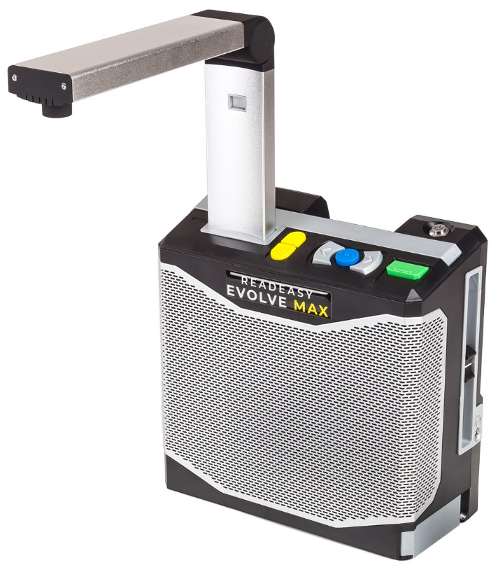
A4 (Letter)
Position

Larger format documents
Fold out the integrated A3 positioning guide, located on the right edge of the unit, at the bottom. There is a finger cut out, 3 inches (7 cm) from the front and the guide pivots outwards, 90 degrees towards you so that it is in line with the front of the unit.
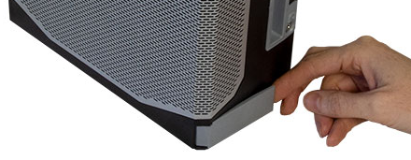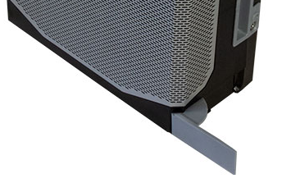

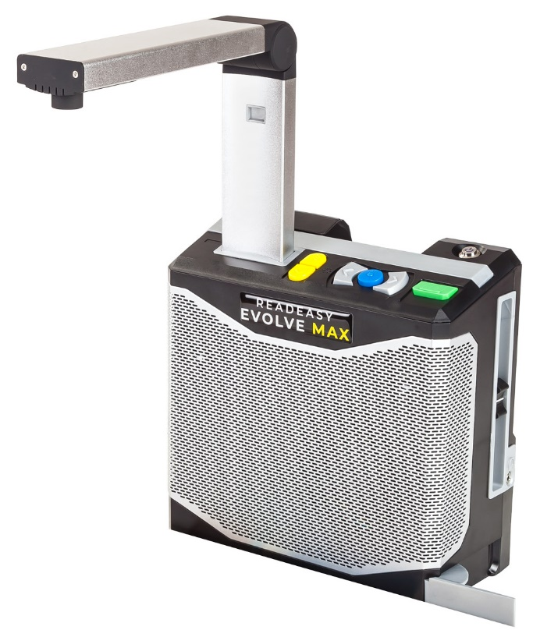

A3 (Tabloid)
Position

Newspapers
For tabloid newspaper pages, orient the page in landscape (long edge running left to right). Now place the long edge up against the front of the ReadEasy Evolve MAX and slide it so that the right edge of your document is aligned with the edge of the positioning guide.

Double A4 spread (e.g. magazine)
Open the magazine fully and ensure the pages are relatively flat. Place the top edge up against the front of the ReadEasy Evolve MAX and slide it so that the right edge of your document is aligned with the edge of the positioning guide.

Thick books, packets or boxes
For the best results, centre the object under the middle of the camera. This is especially important if the object is thick, to ensure all of the object and text can be seen by the camera.

Cylindrical objects (e.g. tins)
Generally, for the best results, place the object directly under the centre of the camera. The part of the object you wish to read needs to be facing upwards towards the camera. This means you may have to rotate the tin and re-capture it several times before it is recognised acceptably. Please note that reflections on cylindrical objects cause more of an issue, so if text is not read accurately, try moving the tin around the capture area before re-capturing.

Positioning Tips
For the absolute best accuracy, try to centre the document under the camera. The camera is located at the front of the camera arm. This may help with extremely small text (5pt), poorer quality print documents or if the document is very thick.

Controls
The main controls are all located on the top edge of the unit at the front. There are 6 tactile buttons.
Each button’s colour, location and shape is fully described later in this section.
Quick press: Next sentence
Press & hold: Next word & spell on release
Quick press: Previous sentence
Press & hold: Previous word & spell on release
Play / Pause

Slower

Faster

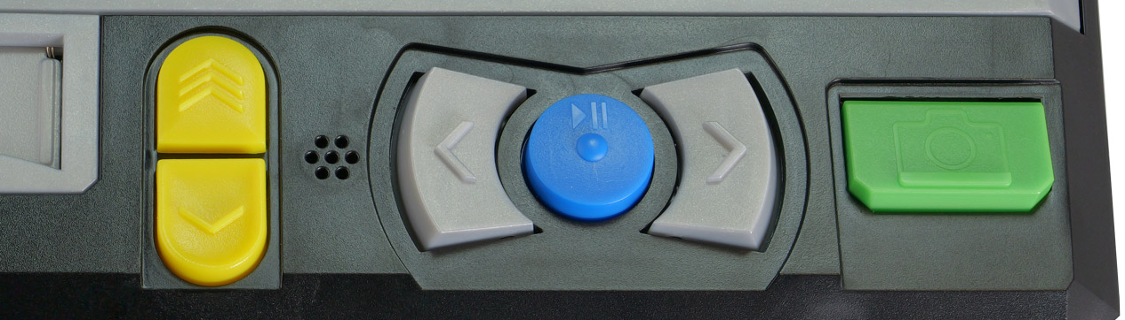
Faster & slower simultaneously:
Change Voice
Quick press: Capture
Press & hold: Table mode (e.g. bank statements)

Capturing a document


Capture (quick press)
To capture a document and have it read aloud, ensure you have a document under the camera and then press the green rectangular button. This is the furthest button to the right and it has a raised tactile line at the bottom of it.
ReadEasy Evolve MAX features an intelligent motion detection system that will not allow your document to be captured if it is moving. This allows you time to press capture and position your document underneath ReadEasy Evolve MAX with both hands (e.g. for a book). Your document will be captured after a safe amount of time after the last movement was detected.
An audible “beep” will be emitted while movement is being detected.
To override this function and force ReadEasy Evolve MAX to capture your document, press Capture again.
Your document will start being read aloud a few seconds later.

Capture as table (press and hold)
To capture documents with tabular information (like bank statements), simply press and hold the capture button until “Capturing as table” is announced. This is the furthest button on the right. This forces ReadEasy Evolve MAX to read across the columns of information.
You may no longer need to do this as the ReadEasy Evolve MAX now features automatic table detection with improved navigation. This is detailed in “Table Navigation” on page 22.

Navigation


Play / Pause
To start and stop the reading of your document, press the play / pause button. This is the blue circular button, located between the two grey crescent buttons. It is the third button from the right. It has a raised bump in its centre.



Next & previous sentence
To navigate forwards or backwards one sentence, press and release the right or left crescent buttons. These are the buttons to the right and left of the Play / Pause button. They have an arrow embossed on them.

Word-by-word with spelling
To navigate forwards or backwards word-by-word, press and hold the next or previous sentence buttons (the right or left crescent buttons). On release the current word is spelt out letter-by-letter.

Next paragraph
+
To navigate to the next paragraph, press and hold the Play / Pause button and quick press the Next sentence button.

Previous paragraph
+
To navigate to the previous paragraph, press and hold the Play / Pause button and quick press the Previous sentence button.

Table navigation
ReadEasy Evolve MAX features automatic table detection. When a table is detected, it can be navigated in a more intuitive way.
You will hear “Entering table” when reading moves into a recognised table.
If ReadEasy Evolve MAX detects a table heading, this will allow you to read through the cells in a table while the headings are announcement automatically.
When in a table, the navigation controls behave slightly differently.

Next and previous cell
To navigate to the next or previous cell, press the Next and Previous Sentence button.
+

Next row
+
To jump down one row, press and hold the Play / Pause button and quick press the Next Sentence button.

Previous row
To jump up one row, press and hold the Play / Pause button and quick press the Previous Sentence button.

Speech Control



Faster & slower
There are a total of 40 voice speeds available. To increase or decrease the reading speed, press the Faster or Slower buttons. These are the two vertically in-line, yellow, half-tablet shaped buttons located on the far left of the buttons, just to the left of the previous sentence button. The top button increases the reading speed and the bottom button decreases the reading speed.

Change voice
To cycle through the reading voices for your document’s language, quick press the Faster and Slower buttons together.

Cycle recognition profiles
+
To cycle through your Recognition Profiles, press and hold the Play / pause button and press the Faster or Slower buttons.
Recognition Profiles can be set up in Main menu – Recognition profiles. This is fully described on page 24.

Main menu
The Main menu contains additional settings for the ReadEasy Evolve MAX.
To access the Main menu, press and hold the Next and Previous sentence buttons together for 5 seconds until “Main menu” is announced.
The Main menu is presented in a vertical list and you always start at the top of the list.
To scroll down through the options, press the Slower button. To scroll up, use the Faster button. To select or choose the current option, press the Play / Pause button. To go back, press the previous sentence button.
The Menu is organised as follows:
- Recognition profiles
- Menu settings
- Advanced settings
- About
- Exit

Recognition profiles
Recognition profiles allow you to adjust how the ReadEasy Evolve MAX recognises your documents.
There are 3 customisable Recognition profiles, making it easy to switch between multiple language and page recognition settings without the need to keep returning to the Main menu.
For example:
Recognition profile 1 could be English, German and French, set to change language on a per page basis (one language allowed per page).
Recognition profile 2 could be English and Spanish set to change language on a per sentence basis (good when learning a language).
Recognition profile 3 could be Welsh.

Active recognition profile
This enables you to select the active recognition profile.

Recognition profile 1, 2, 3
Allows you to configure the following settings for each of the 3 recognition profiles. This is an advanced feature so your local distributor will likely set these before your ReadEasy Evolve MAX is delivered to you or during training.

Start reading when recognition complete (enabled by default)
When enabled, documents start being read out loud as soon as they have been recognised. If you prefer to magnify documents first (available with the optional Feature Pack) disabling this could be useful.

Pause at line breaks (disabled by default)
When enabled, adds a pause at the end of every line. This is useful when reading things such as recipes or lists.

Automatic language detection mode (One language per page by default)
There are 2 options:
- One language per page: This selects the main language on the page from all of the languages you have enabled. e.g. If you have English, and Spanish languages enabled and you capture a page with both these languages present but it contains more Spanish, then the entire page will be read in Spanish.
- Multiple languages per page: This automatically switches between your enabled languages on a sentence-by-sentence basis. E.g. if you have a German language text book and some of the page is in English and some is in German, ReadEasy Evolve MAX will change reading voice automatically between the German and English sentences.

Primary recognition language
When “Automatic language detection mode” is set to “Multiple languages per page”, this makes the selected language more likely to be chosen if the primary language is active.

Available recognition languages
A list of the available recognition languages that the ReadEasy Evolve MAX supports follows Primary recognition language.
The ReadEasy Evolve MAX will look for the enabled languages within any captured document.
We recommend enabling no more than 5 languages per Recognition profile. Enabling more at once is supported but it may reduce the accuracy and speed of recognition (especially if Automatic language detection mode is set to Multiple languages per page).
When enabling a language that does not support automatic language switching, all other languages will automatically be disabled. For a full list of supported languages, please see page 26.
If you regularly need to switch between recognition languages, the 3 customisable recognition presets enable you to do this.

Menu settings

Interface Language
Allows you to choose the Menu / Interface language (the language used in the menus and for announcing events e.g. “capturing”, “faster” etc.).

Interface Voice
Select your preferred Menu / Interface voice (ReadEasy Evolve MAX allows a different reading voice to the interface voice).

Sound effects’ volume
Adjust the volume of the ReadEasy Evolve MAX’s capturing and motion detection sounds.

Advanced Settings

Date and time
Change the date and time, time zone and enable or disable Automatic network time synchronisation (for units connected on a network).
- Bluetooth headset configuration
Allows you to connect and manage Bluetooth audio devices.
To pair a new device, firstly ensure your Bluetooth audio device is in pairing mode (please consult your device’s instructions on how to do this). Then move down and select “Available Bluetooth devices”. ReadEasy will then announce the names of any Bluetooth devices found. Choose your desired device then press the Play / Pause button to connect to it.
By default, ReadEasy should automatically reconnect to the last used device. On some devices you may need to re-pair with the ReadEasy Evolve MAX. To disable this feature, disable the “Automatically connect to last device” option.
To reset the Bluetooth configuration, select “Reset Bluetooth audio device configuration to defaults”.

Feature management
Shows status of ReadEasy Evolve MAX’s features. If you wish to activate another feature (e.g. Asian languages or a different set of voices) please contact your local distributor.

Sentence break
Allows you to adjust the pause between each sentence (in milliseconds).

About
Provides specific information about your ReadEasy Evolve ECO. e.g. Name of product, Software Version and other useful support information.

Languages

Obtaining additional voice sets / features
If you wish to purchase an additional set of voices or a feature pack, please contact your local distributor.

Activating additional voice sets / features
Once you have contacted your distributor and purchased a voice set or feature pack, they will provide you with a coded piece of paper or a file to import via USB memory stick. Capturing or importing this document will automatically unlock and enable the new feature(s).

Supported languages
ReadEasy supports over 40 languages. Please note, some languages do not support automatic switching (they cannot be automatically detected and must be set manually through a different Recognition profile as described on page 23).
The ReadEasy Evolve MAX supports two sets of voices.
The first is the Nuance Vocalizer range of voices. The second is the Ivona set of voices. Depending on your country, you will most likely prefer one or the other once you have heard them. Both sets can be installed on a device but there is an additional charge for this, so each device only includes one set as standard. Please speak to your local distributor for more information.
The full list of supported languages can be found on our website at www.visionaid.com

Upgrading software
ReadEasy Evolve MAX’s software can be upgraded as new versions become available.

Checking your existing software version
To check your current software version, enter the Menu, then go to About and scroll down to Software version.

Determining the latest version available
To find out what the latest available version of the ReadEasy Evolve MAX software is, please contact your local distributor or check on the Visionaid International Ltd website (www.visionaid.com).

Obtaining the latest software
Updated software can either be downloaded from the Visionaid International website or obtained on a USB memory stick from your distributor.
If downloading, the software must be transferred to the root folder of a USB memory stick.

How to upgrade
To install the update, once your ReadEasy Evolve MAX has started and announced it is ready, insert the memory stick into the USB port on the rear of the unit. The ReadEasy Evolve MAX will inform you that it has found an update and ask if you would like to install it. To confirm, press the Play / Pause button, and the upgrade will take place.
To cancel upgrading, select “Cancel” using the Faster or Slower buttons and confirm with the Play / Pause button.

FAQ and Troubleshooting
Here is a list of frequently asked questions and their solutions:
ISSUE: ReadEasy Evolve MAX doesn’t do anything when I press any of the buttons.
Solution 1: Make sure the ReadEasy Evolve MAX is correctly plugged in and turned on and that the volume slider is up. ReadEasy Evolve MAX takes approximately 20 seconds to start and will announce when it is ready. For low vision users, the on / off switch has an illuminated blue ring surrounding it when the unit is powered. Please refer to ‘Plugging in’ on page 8 and ‘Turning on / off’ on page 13 for more information.
Solution 2: If you are not using headphones, ensure that none are connected as the ReadEasy Evolve MAX will automatically mute the volume when they are connected. Please see page 15 for more information on headphones.
ISSUE: When I try to capture a document, after I press capture, ReadEasy Evolve MAX just keeps beeping.
Solution 1: Something is activating the automatic motion detection. If you are capturing a book, ensure the pages are not moving. Also ensure there is nothing else moving in the capture area.
Solution 2: Override the motion detection by simply pressing capture again.
PROBLEM: ReadEasy Evolve MAX doesn’t seem to be reading my entire document.
Solution 1: Ensure your document is correctly positioned. Please see “Positioning Documents for Capture” on page 17.
Solution 3: Is your document thick? If so, the edges of the text might be being cut off during capture. Try repositioning the document under the centre of the camera and capturing again.
PROBLEM: ReadEasy Evolve MAX sometimes reads random characters before and after my document.
Solution: This is normally dealt with automatically but there may be some table cloth patterns or wood grain surfaces that might cause an occasional issue. If your unit is on a patterned or grained surface, try moving your ReadEasy Evolve MAX to a clear surface to see if it solves the problem.
PROBLEM: ReadEasy Evolve MAX is reading words incorrectly in roughly the same location on each page.
Solution: Ensure you are not capturing a glossy document with ReadEasy Evolve MAX’s lights on. Please see page 16, ‘Lighting on / off’ for details on how to turn the lights on and off.
Also please check you don’t have ceiling lighting close by which may be causing reflections on your document.
PROBLEM: ReadEasy Evolve MAX is telling me the camera is not connected.
Solution 1: Ensure the camera is correctly located into its slot on top of the machine. For more information, please see “Plugging in the camera” on page 11.
Solution 2: Turn off the ReadEasy Evolve MAX (if it is on). Then disconnect the camera and the power cable going into the back of the ReadEasy Evolve MAX. Leave the unit unplugged for 10 minutes. Then, re-connect the power cable, locate the camera into its socket and turn the ReadEasy Evolve MAX back on.

Terms and conditions of sale
This product is guaranteed from manufacturing faults for 24 months from the date of purchase. If you have any issues with the product and you did not purchase directly from Visionaid International then please contact your retailer in the first instance.
For all returns and repairs, contact your authorised distributor.


This product is CE and UKCA marked and fully complies with all applicable UK and EU legislation.
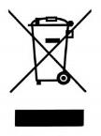
The WEEE logo on the product or its box indicates that this product must not be disposed of or dumped with your other household waste. You are liable to dispose of all your electrical waste equipment by taking it to a specified collection point for recycling of hazardous waste. Isolated collection and proper recovery of your electronic and electrical waste equipment at the time of disposal will help conserve natural resources. Moreover, proper recycling of electrical waste equipment will ensure human and environmental health. For more information about electronic and electrical waste disposal, recovery, and collection points, please contact your local authority, household waste disposal service, shop from where you purchased the equipment, or Visionaid International Ltd.
© Visionaid International 2026

Appendix A: Technical Information
General information
Footprint (WxD) | 220 x 110 mm  8.7 x 4.3 inches
Unit dimensions (camera detached) (WxDxH) | 220 x 110 x 205 mm  8.7 x 4.3 x 8.1 inches
Unit dimensions (camera attached) (WxDxH)  (footprint remains unchanged) | 220 x 280 x 370 mm  8.7 x 11 x 14.6 inches
Weight: | 1.98 kg (4.4 lbs)
Camera: | 18MP
Headphone connection: | 3.5 mm stereo jack

Operating conditions
Relative Humidity: | <70%, no condensation
Temperature: | 10 to 35 °C

Storage and transport conditions
Relative humidity: | <95%, no condensation
Temperature: | 0 to 40 °C

