

Quick Reference Guide v1.3

Removing & Connecting the Camera
- The camera is stored at the back of the unit, along the bottom. With the unit facing towards you, run your fingers 1 inch (2.5cm) up the back of the left edge. You will feel a half circle shaped cut-out. Push the camera head backwards via this recess & fully remove it.
- Unfold the camera
- Locate the camera slot, positioned on the top of the unit, at the front, 1.4 inches (3.5cm) from the left-hand side.
- With the shorter arm (containing the USB port) facing downwards & the other part of the arm facing towards you, angle the camera head a few degrees forwards & gently insert into the camera slot.
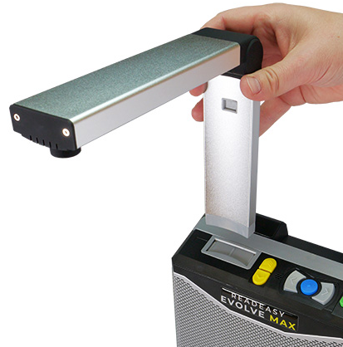
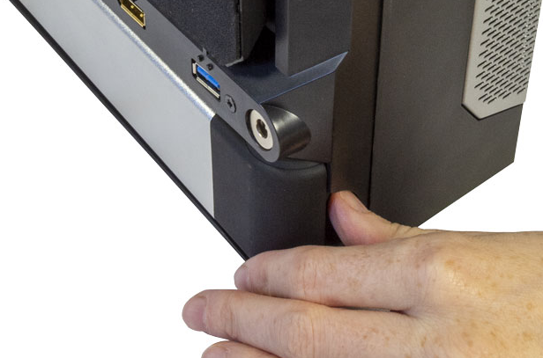

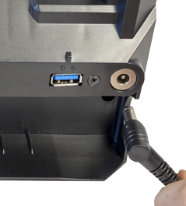
Plugging In
Plug the tip of the power brick into the unit’s power socket, located on the rear of the unit, on the far-right hand-side, 2.5 inches (6cm) up (a round area with a round recess). Ensure the power brick’s cable is plugged in and connect it to the mains.

Turning On / Off
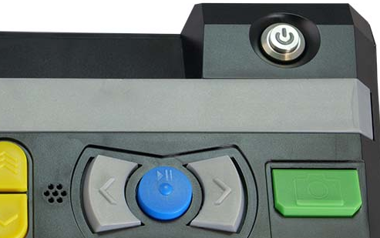
The on / off button is located on the top back right of the machine. It is a round button recessed in a round hole. It illuminates blue when the device is on. It takes 20 seconds for ReadEasy to start & announce it is ready.
On / Off

Positioning Documents for Capture
Align the top edge of A4 (Letter) documents with the front of the unit.
Align A3 (Tabloid), magazines and larger documents in landscape (long edge left-to-right). Push the document up against the unit and slide it right so that the right edge of the document is in line with the edge of the opened fold-out positioning guide.
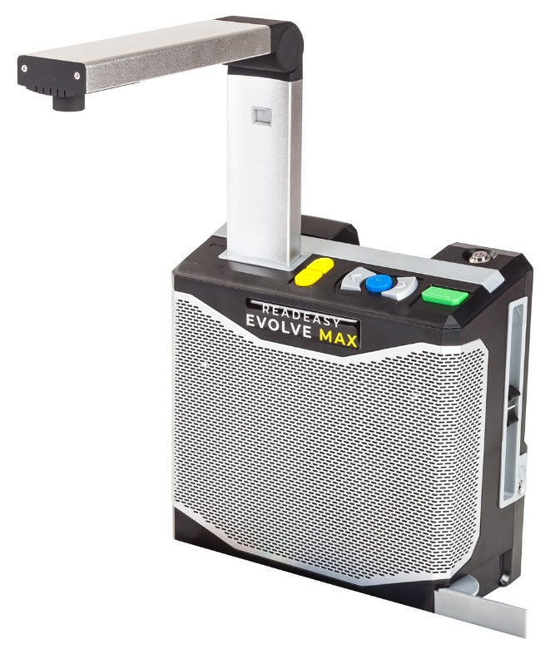
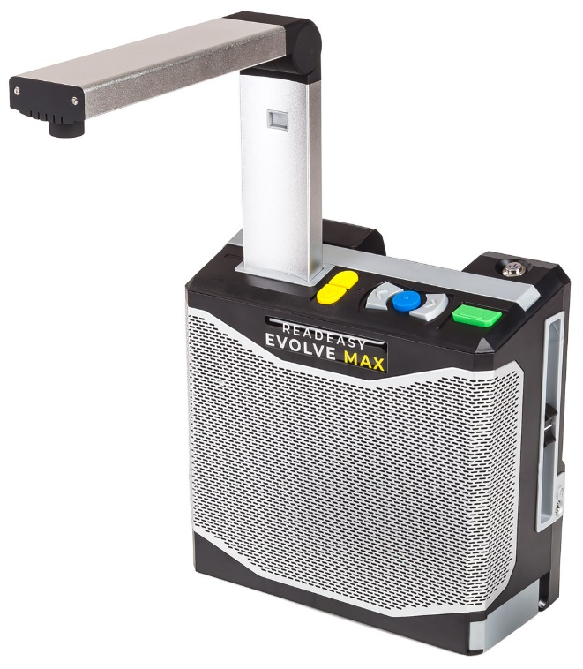
For thick books, packets, boxes or cylindrical objects, position them directly below the centre of the camera for best results.

A4 (Letter)
Position

A3 (Tabloid)
Position

Controls
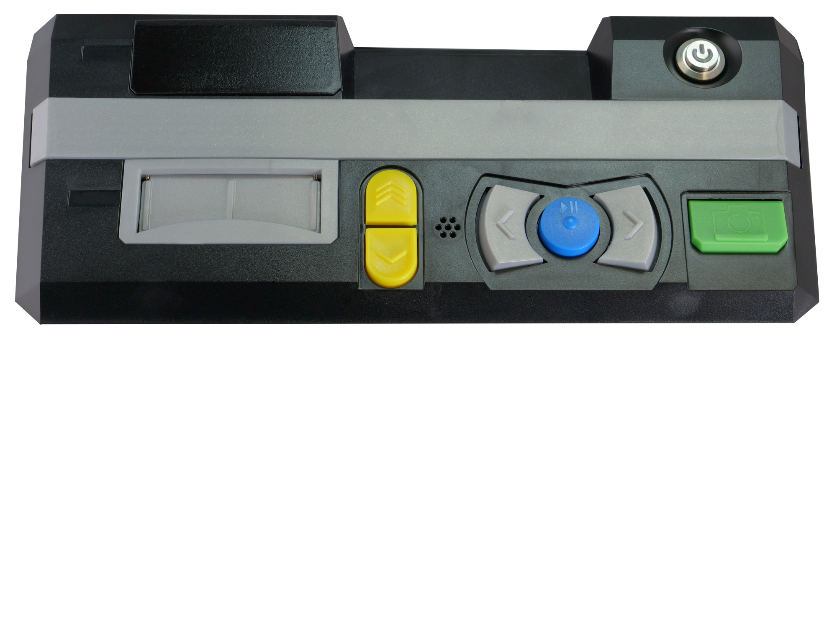
1
2
3
4
5
6
1: Capture (quick press) – Green rectangular button located on the far right. It has a raised tactile line at the bottom.
Capture as Table (press & hold) – Only to be used when table documents are not automatically recognised correctly.

2: Play / Pause – Blue circular button located between the two grey crescent buttons. It has a raised bump in the centre.

3, 4: Next & Previous sentence – Grey right & left crescent buttons located to the right & left of the Play / Pause button. They have raised right & left arrows in the middle of them.
Next & Previous cell (when in table)
Press & hold 3 or 4: Next & Previous word (with spelling on release)
Press & hold 2 & quick press 3 or 4 : Next & Previous Paragraph
Next & Previous Row (when in table)

5, 6: Faster & Slower – Yellow, in-line, half-tablet shaped buttons on the far left. They have up and down facing arrows on them.
5 & 6 together: Cycle Reading Voice
Press & hold 2 & quick press 5 or 6: Cycle Recognition Profiles

Additional Controls
For additional controls, such as enhanced navigation and changing recognition profiles, please read the complete user manual.

Volume and Headphones socket
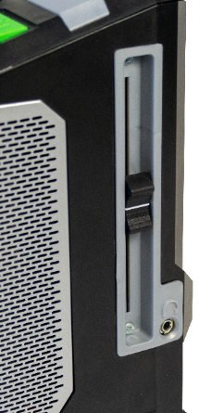
To increase or decrease the volume, raise or lower the volume slider. This is located on the right edge of the machine, 1.5 inches (4 cm) from the back.
Volume Slider
To use the included headphones (or any others with a 3.5mm jack), plug them into the headphone socket. This is located on the right-hand edge of the machine, at the bottom of the volume slider section.
Headphone Socket
(3.5mm Stereo)

Assistance

If you have any queries with the operation of your ReadEasy Evolve MAX, please contact your local distributor.

Designed and Manufactured by
Visionaid International Ltd

Bridge Lodge, Telephone:
Spalding Common, +44 (0)1775 711 977
Spalding, Lincolnshire
PE11 3AU Email:
United Kingdom info@visionaid.com

