
Readit Lite v1.1: Quick Reference - Rev B
 | Menu | Menu /  Application Key
 | Zoom Out (Optical)  Zoom In (Optical) | Ctrl + Shift + -  Ctrl + Shift + +
 | Toggle Focus Lock | F
 | Focus Nearer  Focus Farther | F + -  F + +
 | Change Colour Mode | C  Shift + C (back)
 | Decrease Contrast  Increase Contrast  Reset Contrast | -  +  0
 | Change Camera Target (Document available only with CoaSt Duo) | T  Shift + T (back)
 | Change Rotation (Document Target Only) | R  Shift + R (back)
 | Toggle Video Stabilisation  (Distance Target Only) | S
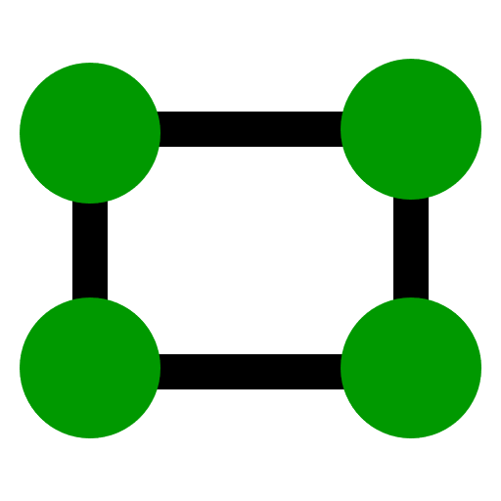 | Perspective Correction (Distance Target Only) | No Shortcut Key
 | Toggle Freeze Frame | Z
 | Save Image | Enter
 | Change Camera Resolution / Frame Rate | No Shortcut Key

General
 | Settings | F10
 | Toggle Full Screen | F11
Additional Camera Controls
 | Reset Optical Zoom | Ctrl + Shift + 0
 | Toggle Optical Zoom Overview | O
 | Copy to Clipboard | Ctrl + C
Image Controls
 | Decrease Digital Zoom  Increase Digital Zoom | Ctrl + -  Ctrl + +
 | Zoom to Fill | Ctrl + 0
 | Zoom to Fit | Ctrl + Alt + 0
1 : 1 | Zoom to Actual Size | Ctrl + 1
 | Change Colour Combination | L / Shift + L (back)
 | Pan | Arrow Keys
 | Pan to Edge of Digital View | Ctrl + Arrow Keys
 | Continuous Panning | Alt + Arrow Keys
 | Next Screen to the Left  Next Screen to the Right  Next Screen Above  Next Screen Below | Shift + Pg Up or < Shift + Pg Dn or >  Page Up  Page Down
 | Go to Beginning / Go to End | Home / End

Camera buttons: | Zoom In / Out or Focus Nearer / Farther
Toggle Autofocus / Manual Focus: | Quick press Zoom In + Out together for 3 secs
Toggle Closeup & Distance Mode: | Quick press Zoom In + Out together  * CoaSt Duo only *
