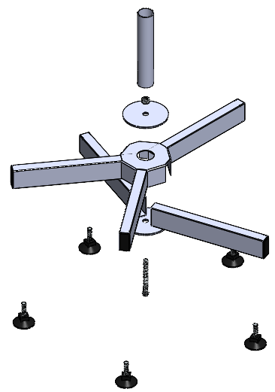  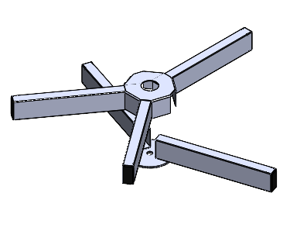      C  G  E  A  B  H  I  F  D | What’s in the box?:  A 1x Upper section (three prong)  B 1x Lower section (two prong)  C 1x M8 x 70 Bolt  D 1x Washer  E 1x Nut  F 1x Threaded spigot tube  G 5x Threaded feet  H 1x Spanner  I 1x Allen key
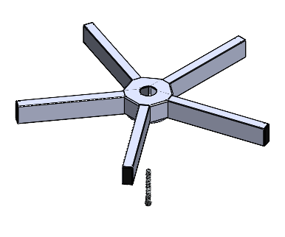  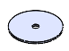 | Take the Upper section and the Lower section and slot together as shown.  Centre the Washer on top, with the holes aligned through the middle insert the Bolt through the bottom.
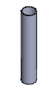  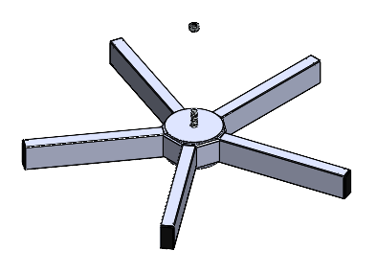 | Thread the Nut onto the end of the bolt, use the Spanner to turn the Nut and the Allen key to hold the Bolt, to tighten until the assembly is secure with no rattle or movement but avoid over tightening.  Screw by hand the Threaded spigot tube onto the Bolt until it makes contact with the surface or no longer turns by hand.  Make sure this component is properly hand tightened before use of the base.
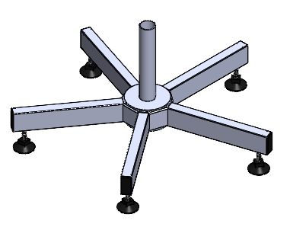  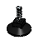 | Take the five Threaded feet and screw them into the threaded holes at the bottom of each end of each prongs.  Test the base on the floor where you intend to use it as any bumps or slopes may cause the base to rock back and forth, adjust any feet that are not touching the floor by screwing them out until they make contact with the floor. The base is now fully assembled and ready for use.


