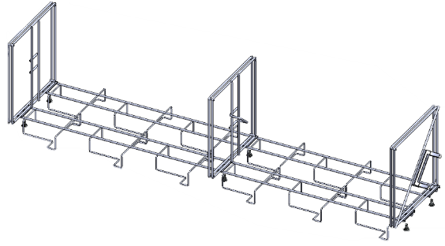  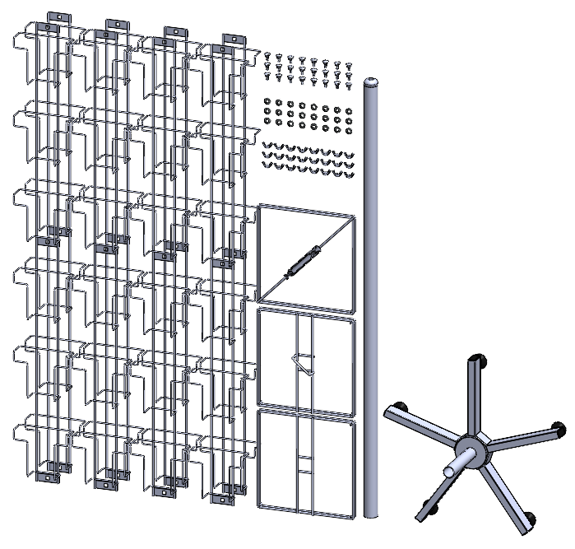  B  C  D  I  H  A  E  G  F |   What’s in the box:  A. 8x Pocket Panel  B. 1x Top Core  C. 1x Middle Core  D. 1x Bottom Core  E. 24x Bolts  F. 24x Washers  G. 24x Wingnuts  H. 1x Pole  I . 1x Base (see 5 Way Base Assembly Instructions)
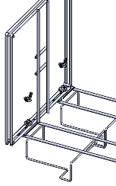  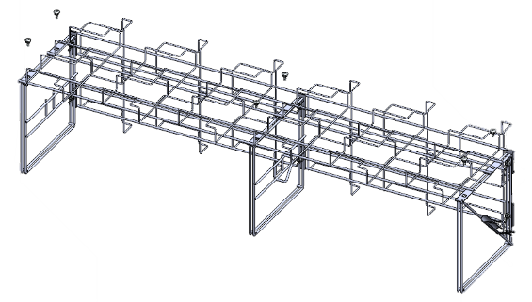  G  F  E  B  C  D | Find a flat surface and lay down two of the Pocket Panels side by side, then hold the Bottom Core against the holes in the plate at the bottom end of the Panels and insert the Bolts up through the Panel, put the Washer and Wingnut over the Bolt and loosely hand tighten, repeat with the Middle core and the Top Core. Gently pull the Cores towards one side to offset them evenly along the length of the stand.
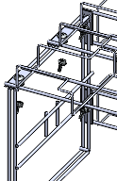 | Roll the whole assembly so that the Pocket Panels are facing to the side and place the next two Pocket Panels on top of the Cores. Insert all six Bolts through the plates on the Pocket Panels and through the Cores, add the Washers then the Wingnuts from underneath and loosely tighten all by hand one by one.
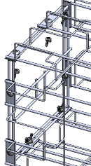  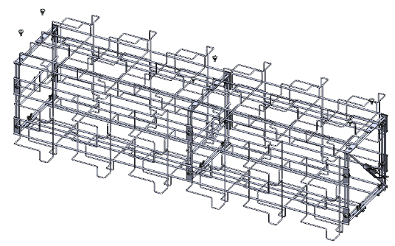  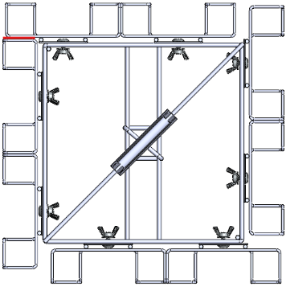  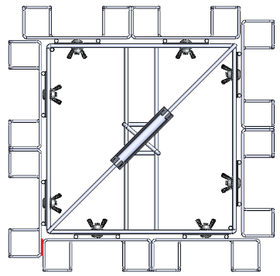 | Roll the stand so Pocket Panels can be attached on top. Repeat until all Pocket Panels are fixed to the stand.  Once all Pocket Panels are attached, pick the unit up and stand it upright.
 | Looking at the stand from above you’ll need to slide the Pocket Panels sideways to ensure equal spacing, on the left example the red highlight shows where the pockets need to sit - up against the back of the next, repeat this clockwise four times until it looks like the example on the right. When you’re happy with the alignment tighten down all Wingnuts.
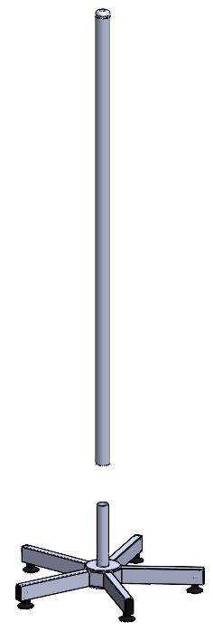  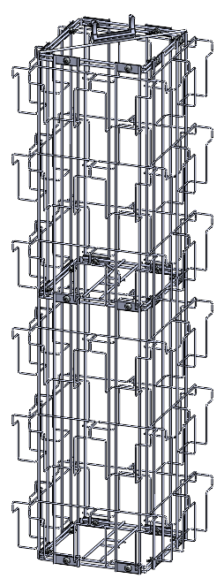  H | Take the Pole and slot it over the Threaded spigot.
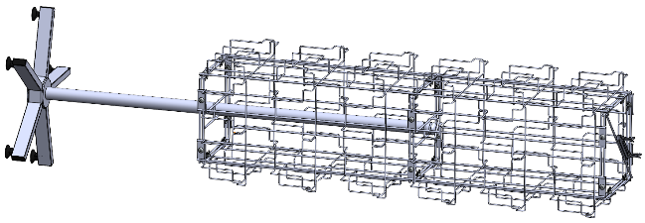  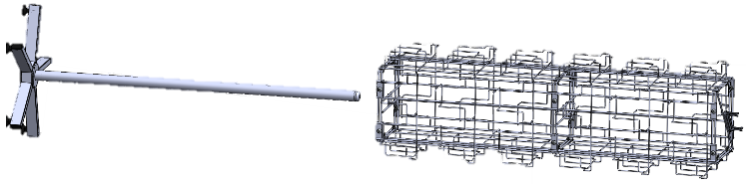  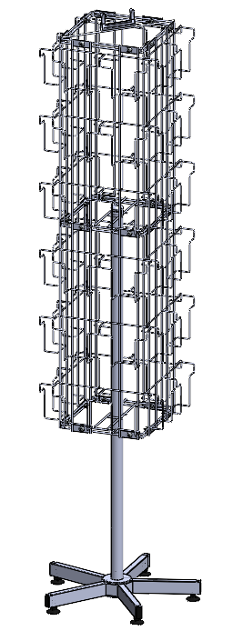  I | Tip the stand and the Pole onto their sides.  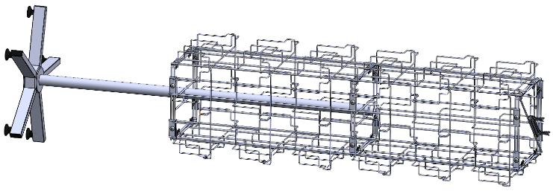  Push the Pole through the centre of the Bottom core until it hits the centre of the Middle core.  When in place the unit can be stood upright.
 | Your stand is complete, you can now load it with products, make sure to load evenly on opposite sides to avoid imbalances when turning.
