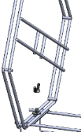  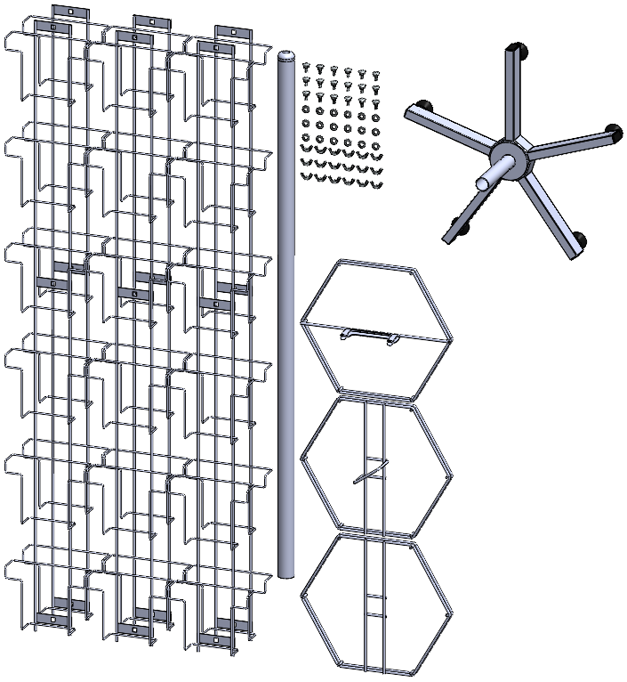  H  F  G  E  I  C  B  A |   What’s in the box:  A. 6x Pocket Panel  B. 1x Top Core  C. 1x Middle Core  D. 1x Bottom Core  E. 18x Bolt  F. 18x Washer  G. 18x Wingnut  H. 1x Pole  I. 1x Base (see 5 Way Base Assembly Instructions)
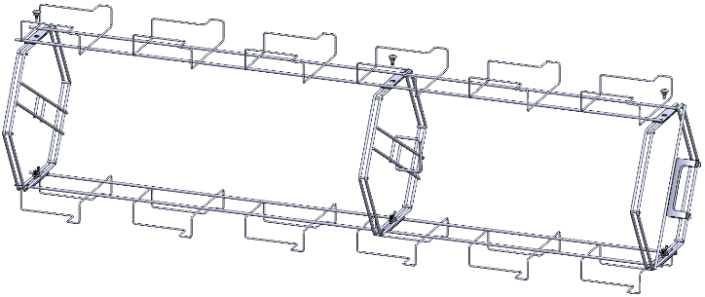  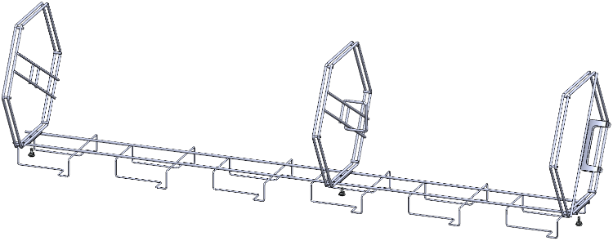  G  F  B  C  D  D | Find a flat surface and lay down a Pocket Panel, then hold the Bottom Core against the holes in the plate at the bottom end of the Panel and insert the Bolts up through the Panel, put the Washer and Wingnut over the Bolt and loosely hand tighten, repeat with the Middle core and the Top Core.
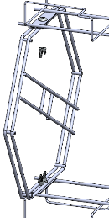  E  A | Place the next Pocket Panel on top of the Cores. Insert all three Bolts through the plates on the Pocket Panel and through the Cores, add the Washers then the Wingnuts from underneath and loosely tighten all by hand one by one.  Roll the stand and place it on the next Pocket Panel. Then place the next Pocket Panel on top of the Cores. Repeat for the next set of Panels
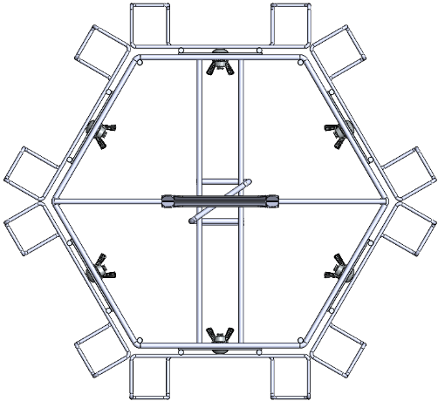 | Once all Pocket Panels are attached, pick the unit up and stand it upright.  Looking at the stand from above you’ll need to centre the Pocket Panels on the Cores to ensure equal spacing, when you’re happy with the alignment tighten down all Wingnuts.
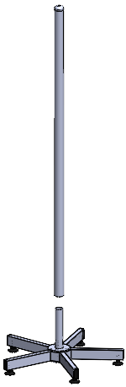  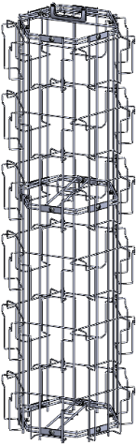  H | Take the Pole and slot it over the Threaded spigot.
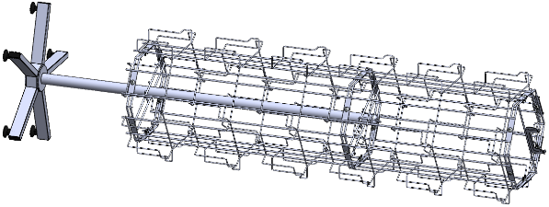  I | Tip the stand and the Pole onto their sides.  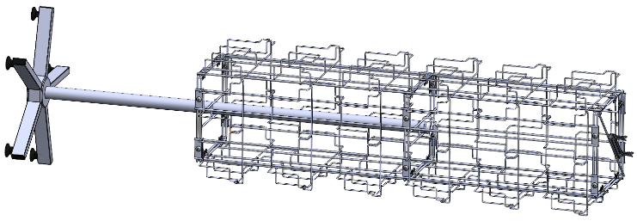  Push the Pole through the centre of the Bottom core until it hits the centre of the Middle core.  When in place the unit can be stood upright.
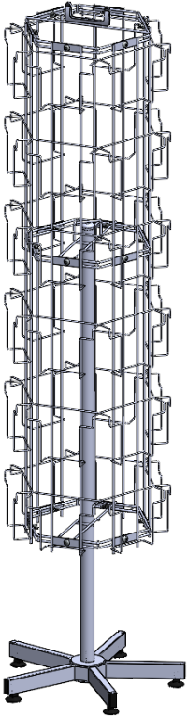 | Your stand is complete, you can now load it with products, make sure to load evenly on opposite sides to avoid imbalances when turning.
